Date: 19.03.2021
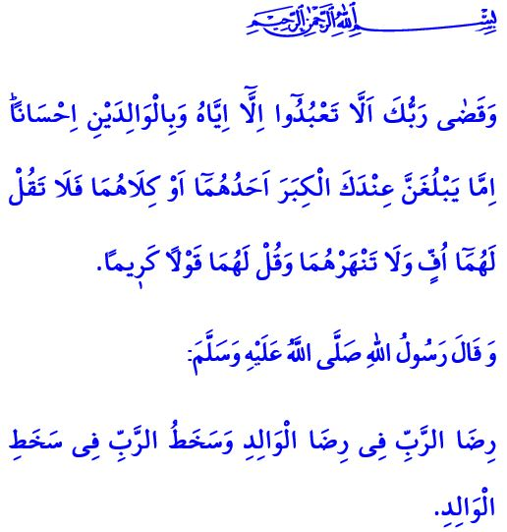
PLEASURE OF OUR PARENTS CONDUCES TO PLEASURE OF ALLAH
Dear Believers!
Our parents, who has brought us to this world, spent years striving to raise and educate us so that we develop a healthy character. For this reason, our sublime religion orders that we be on good terms with our parents, treat them with reverence, and protect their rights. It tells us that being supportive of our parents in the face of difficulties both materially and spiritually, showing them affection and compassion, and meeting their needs especially when they reach old age is a duty of loyalty upon us. In this sense, it is stated in the Holy Qur’an as follows, “Your Lord has decreed that you worship not except Him, and to parents, good treatment. Whether one or both of them reach old age [while] with you, say not to them [so much as], “uff”, and do not reprehend them, but address them in terms of honor. And lower to them the wing of humility out of mercy and say, “My Lord, have mercy upon them as they brought me up [when I was] small.”
Dear Muslims!
Our Lord (swt), who has created us from nothing, has entrusted us to our closest people for us to stay with them until an age when we become believing servants able to assume responsibility. Our parents have brought us to these days with patience and sacrifice, love and mercy, and tears and supplications at times, and with the light of their eyes and sweat of their brows at other times. For this reason, when one day a man asked the Prophet Muhammad (saw), “What is the most superior of all good deeds?”, he replied, “The salah that is performed right on its time, and treating the parents properly. Then, to participate in jihad in Allah’s cause.”
Dear Brothers and Sisters!
Let us not withhold our kindness and benevolence, a couple of nice words and smiling face, respect and tolerance from our parents. Let us strive to win their hearts and deserve to be blessed with their supplications for us. Let us view their supplications to Allah (swt) for us as our blessing in this world and our means for salvation in the Hereafter. Let us never forget the following warning of the Prophet Muhammad (saw), “The pleasure of the Lord lies in the pleasure of the parent. The anger of the Lord lies in the anger of the parent.”

Isra, 17/23-24.
Bukhari, Tawhid, 48.
Tirmidhi, Birr, 3. General Directorate of Religious Services

